Copyright for test papers and marking guides remains with *West Australian Test Papers*.

The papers may only be reproduced within the purchasing school according to the advertised conditions of sale.

Test papers must be withdrawn after use and stored securely in the school until 12th October 2016.

**HUMAN BIOLOGY**

**Units 3 and 4**

**2016**



Name: _______________________________________________________

Teacher: ___________________________________________________

***TIME ALLOWED FOR THIS PAPER***

Reading time before commencing work: Ten minutes

Working time for the paper: Three Hours

***MATERIALS REQUIRED/RECOMMENDED FOR THIS PAPER***

**To be provided by the supervisor:**

* This Question/Answer Booklet
* Multiple Choice Answer Sheet

**To be provided by the candidate:**

* Standard items: Pens, pencils, eraser or correction fluid, ruler, highlighter, ruler.
* Special items: Calculators satisfying the conditions set by the Schools

Curriculum and standards authority for this subject.

***IMPORTANT NOTE TO CANDIDATES***

No other items may be taken into the examination room. It is **your** responsibility to ensure that you do not have any unauthorised notes or other items of a non-personal nature in the examination room. If you have any unauthorised material with you, hand it to the supervisor **before** reading any further.

***Structure of this paper***

|  |  |  |  |  |  |
| --- | --- | --- | --- | --- | --- |
| Section | Suggested working time | Number of questions available | Number of questions to be attempted | Marks | Percentage |
| SECTION ONE:  Multiple-choice | 40 minutes | 30 | All | 30 | 30 |
| SECTION TWO:  Short answers | 90 minutes | 7 | All | 100 | 50 |
| SECTION THREE:  Extended answers | 50 minutes | 3 | 2 | 40 | 20 |
|  |  |  | Total marks | 170 | 100 |

**Instructions to candidates**

1. The rules for the conduct of Western Australian external examinations are detailed in the *Year 12 Information Handbook 2016.* Sitting this examination implies that you agree to abide by these rules.

2. Answer the questions according to the following instructions.

Section One: Answer all questions on the separate Multiple-choice Answer Sheet provided. For each question shade the box to indicate your answer. Use only a blue or black pen to shade the boxes. If you make a mistake, place a cross through that square, do not erase or use correction fluid, and shade your new answer. Marks will not be deducted for incorrect answers. No marks will be given if more than one answer is completed for any question.

Sections Two and Three: Write your answers in this Question/Answer Booklet.

3. You must be careful to confine your responses to the specific questions asked and to follow any instructions that are specific to a particular question.

4. Spare pages are included at the end of this booklet. They can be used for planning your responses and/or as additional space if required to continue an answer.

* Planning: If you use the spare pages for planning, indicate this clearly at the top of the page.
* Continuing an answer: If you need to use the space to continue an answer, indicate in the original answer space where the answer is continued, i.e. give the page number. Fill in the number of the question(s) that you are continuing to answer at the top of the page.

**Section One: Multiple-choice 30% (30 Marks)**

This section has **30** questions. Answer **all** questions on the separate Multiple-choice Answer Sheet provided. For each question shade the box to indicate your answer. Use only a **blue or black pen** to shade the boxes. If you make a mistake, place a cross through that square, do not erase or use correction fluid, and shade your new answer. Marks will not be deducted for incorrect answers. No marks will be given if more than one answer is completed for any question.

Suggested working time: 40 minutes.

1. Many factors affect fossil formation. Which of the following environments is an organism **most likely** to be preserved as a fossil?
   1. Forest floor
   2. Sea floor
   3. Coastal beach
   4. Active glacier
2. A person’s brain is injured in an accident resulting in the person unable to regulate temperature, hunger and water balance. Which of the following parts of the person’s brain was affected?
   1. Hypothalamus
   2. Medulla Oblongata
   3. Cerebellum
   4. Forebrain
3. Select the **best** description of a virus.
   1. A non-cellular living organism.
   2. A small form of bacteria.
   3. A cell at the boundary between the living and non-living.
   4. Chemical complexes of RNA or DNA protected by protein.
4. Dermatitis is inflammation of the skin. Choose the best description of an inflammatory response.
   1. An internal non-specific defence as a response to invading pathogens.
   2. An antibody-mediated specific response to infection.
   3. A cell-mediated specific response to infection.
   4. An internal non-specific defence as response to tissue damage.
5. Which of the following strategies would help restore a high body temperature to normal?
   1. Goosebumps
   2. Redistribution of blood flow away from the periphery
   3. Piloerection
   4. Sweating
6. An increase in respiration rate is a homeostatic response to
   1. decreased oxygen levels in the blood.
   2. decreased carbon dioxide levels in the blood.
   3. increased pH of the blood.
   4. increased concentration of hydrogen ions in the blood.
7. Which of the following is true about synapses?
   1. Neurotransmitters bind to receptors on both the post- and pre-synaptic knobs, causing ion-specific channels to open.
   2. Only excitatory signals can be sent across synapses.
   3. Neurotransmitter receptors at the synapse are coupled to ion-specific channels.
   4. A neuromuscular junction is the synapse between a nerve and a gland.
8. A strong stimulus can increase the
   1. frequency of the action potentials.
   2. the concentration of neurotransmitters within each vesicle.
   3. minimal threshold needed for the all-or-none response.
   4. speed of the impulse travelling down the axon.
9. For Natural Selection to occur, mutations must be
   1. germline.
   2. morphologic.
   3. somatic.
   4. autonomic.
10. Bactericidal antibiotics work by
    1. inhibiting the production of all enzymes.
    2. disrupting the process of protein synthesis.
    3. disrupting the action of essential enzymes.
    4. inhibiting bacteria from reproducing.
11. Gene therapy is a technique that has the ability to treat inherited diseases by
    1. replacing faulty genes with healthy copies
    2. repairing the faulty gene.
    3. restoring healthy tissues or organs.
    4. removing the faulty gene.

Question 12 refers to the Karyotype below.

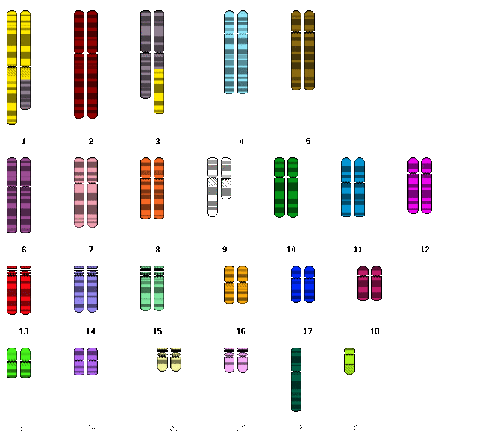

1. What are the two types of chromosomal mutations seen in the Karyotype above?
2. Translocation; Addition
3. Duplication; Inversion
4. Translocation; Deletion
5. Duplication; Non-disjunction
6. Tool use is providing an insight to the evolution of hominid lifestyles. Which of the following is suggested to be the main use of the Acheulian tools?
   1. To build fires.
   2. To groom.
   3. To process meat and hides.
   4. Undetermined.
7. In the biotechnological technique Polymerase Chain Reaction, a synthetic sequence of nucleotides is involved in which of the following steps?
   1. Denaturing
   2. Priming
   3. Annealing
   4. Elongation

Question 15 refers to the diagram below.

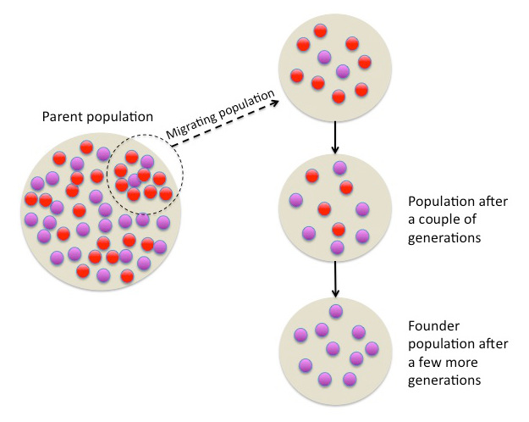

1. The diagram above is best representative of
   1. random genetic drift.
   2. the Founder effect.
   3. migration.
   4. natural selection.
2. The somatic nervous system is responsible for
   1. maintaining homeostasis within the internal environment.
   2. receiving and sending information as interaction with the outside environment.
   3. regulating the endocrine system.
   4. interactions between the brain and spinal cord.
3. Which of the following species, which lived approximately 3.8 million years ago, gave rise to at least two branches of hominids: the later australopithecines and the genus *Homo*?
   1. *H. habilis*
   2. *A. africanus*
   3. *P. robustus*
   4. *A. afarensis*

Question 18 refers the diagrams below.

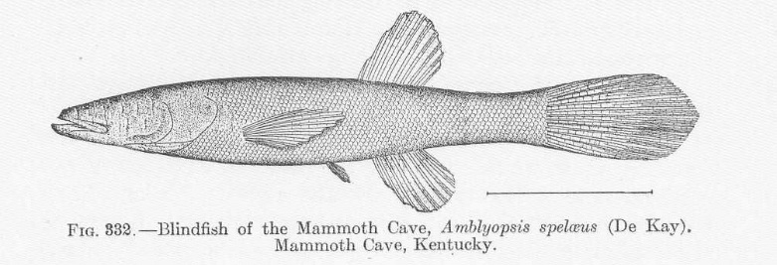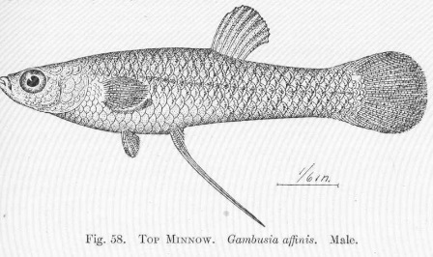

1. The Cave Fish and the Minnow are related species, but the cave fish is blind. What type of comparative study is best represented by this example?
   1. Embryology
   2. Homologous Structures
   3. Vestigial Organs
   4. Comparative Anatomy
2. Absolute dating methods have provided valuable information in the study of human origin. A timber circle, known as Seahenge, was discovered in 1998 off the coast of England and dated back to 2049BC. Which of the following methods would have most likely been used in this dating procedure?
   1. Stratigraphy and radiocarbon dating
   2. Dendrochronology and Fluorine dating
   3. Carbon-14 and thermoluminescence
   4. Dendrochronology and radiocarbon dating
3. Which of the following describes the order of processes associated with DNA Fingerprinting?
   1. DNA Isolation 🡪 Restriction Enzymes 🡪 Electrophoresis
   2. DNA Isolation 🡪 Electrophoresis 🡪 Restriction Enzymes
   3. Restriction Enzymes 🡪 DNA Isolation 🡪 Electrophoresis
   4. Restriction Enzymes 🡪 Electrophoresis 🡪 DNA Isolation
4. The correct order of human ancestors from oldest to youngest is
   1. *Homo habilis, Homo erectus, Homo neanderthalensis, Homo sapiens*
   2. *Homo sapiens, Homo habilis, Homo erectus, Homo neanderthalensis*
   3. *Homo neanderthalensis, Homo habilis, Homo sapiens, Homo erectus*
   4. *Homo erectus, Homo neanderthalensis, Homo sapiens, Homo habilis*

Question 22 refers to the diagram below of primate dental arcades.

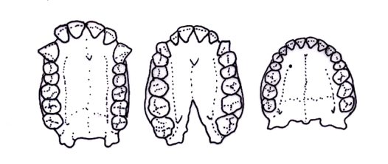

A B C

1. Primate dentition, including dental arcade, are suggested to have evolved due to dietary changes. The dental arcade of Primate C has a more parabolic pattern than Primate A because Primate A is
   1. human and requires distinct gaps between the incisors and canines.
   2. an ape and requires smaller and narrower teeth.
   3. human and requires smaller molars due to changes in diet.
   4. an ape and requires larger molars for grinding their food.
2. Helper T-cells play an important role in both humoral and cell-mediated immunity. Which of the following is **not** an action of Helper T-cells?
   1. Intensify the cell-mediated response.
   2. Attract macrophages to the site of infection.
   3. Increase phagocytic activity.
   4. Migrate, attach and secrete substances to destroy pathogens.
3. Advantages of bipedal locomotion and erect stance include all except which of the following?
   1. Free hands to carry food and for tool use
   2. Improved heating of the body
   3. Increased size to deter predators
   4. Increased range of vision

Questions 25 and 26 refer to the diagram below of the half-life of Potassium-40.

1. Using the graph, calculate the half-life of Potassium-40.
   1. 1.3 billion years
   2. 2.0 billion years
   3. 50 billion years
   4. 6.0 billion years
2. Potassium-40 decays into Argon-40. If a sample was found to be 3.2 billion years old, what approximate percentage of Argon-40 would be present?
   1. 80%
   2. 90%
   3. 60%
   4. 70%
3. Within a small population, changes in gene frequencies that occur due to chance events are is known as
   1. mutation.
   2. natural selection.
   3. sexual selection.
   4. genetic drift.
4. Pathogens are neutralised and eliminated during acute inflammatory responses. All of the following are stages in the inflammatory response except
   1. clots, due to release of heparin, form to limit the spread of the pathogens.
   2. increased numbers of leukocytes arrive at site due to increased blood flow.
   3. temperature of site increases to inhibit pathogen growth due to blood leakage into tissue.
   4. phagocytes engulf and digest dead cells and pathogens producing pus.
5. Tay-Sachs disease causes the deterioration of nerve cells. Which of the following characteristics indicates that this disease has a heterozygote advantage based on Natural Selection?
   1. The disease appears in pedigrees with no known family history.
   2. Frequency is greater in the Ashkenazi Jewish population than other Caucasian populations.
   3. The disease results in death at a very young age due to the nerve damage.
   4. All of the above.
6. The body’s external defence mechanisms against pathogens includes features of many body systems. All of the following physical barriers can help prevent pathogens via low pH (acidity) levels except:
   1. respiratory system.
   2. urogenital tract.
   3. digestive tract.
   4. integumentary (skin) system.

**Section Two: Short answer 50% (100 Marks)**

This section has **seven (7)** questions. Answer **all** questions. Write your answers in the spaces provided. Spare pages are included at the end of this booklet. They can be used for planning your responses and/or as additional space if required to continue an answer.

* + Planning: If you use the spare pages for planning, indicate this clearly at the top of the page.
  + Continuing an answer: If you need to use the space to continue an answer, indicate in the original answer space where the answer is continued, i.e. give the page number. Fill in the number of the question(s) that you are continuing to answer at the top of the page.

Suggested working time: 90 minutes.

**Question 31 (8 marks)**

The endocrine system produces a variety of hormones, including the sex hormones, such as testosterone and oestrogen. These are examples of lipid-soluble hormones. Consider each of the following mechanisms of hormone action.

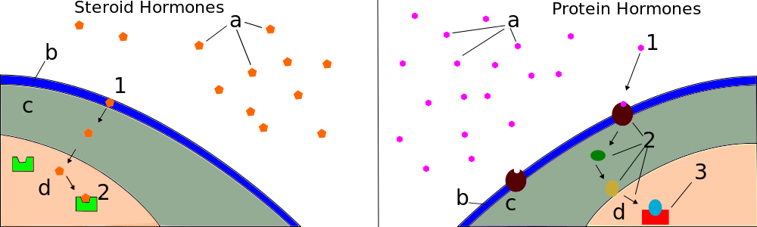

Model A Model B

1. State the model, A or B, that best corresponds to the mechanism of lipid-soluble hormones (1 mark)

___________

1. State why Model B would result in short-lived responses. (1 mark)

__________________________________________________________________________________________________________________________________________________

1. Hormones elicit responses via different mechanisms. State **two (2)** ways in which hormones exhibit their effects. (2 marks)

___________________________________________________________________________________________________________________________________________________________________________________________________________________________

1. The hypothalamus and pituitary gland are joined by a stalk called the infundibulum. State how the hypothalamus controls secretions from the anterior and posterior lobe of the pituitary gland. (2 marks)

Anterior lobe: ______________________________________________________________

Posterior lobe: _____________________________________________________________

A group of volunteers were tested for plasma solute concentration, plasma antidiuretic hormone (ADH) concentration and feelings of thirst. The graph below shows the relationship between intensity of thirst, plasma ADH concentration and plasma solute concentration.

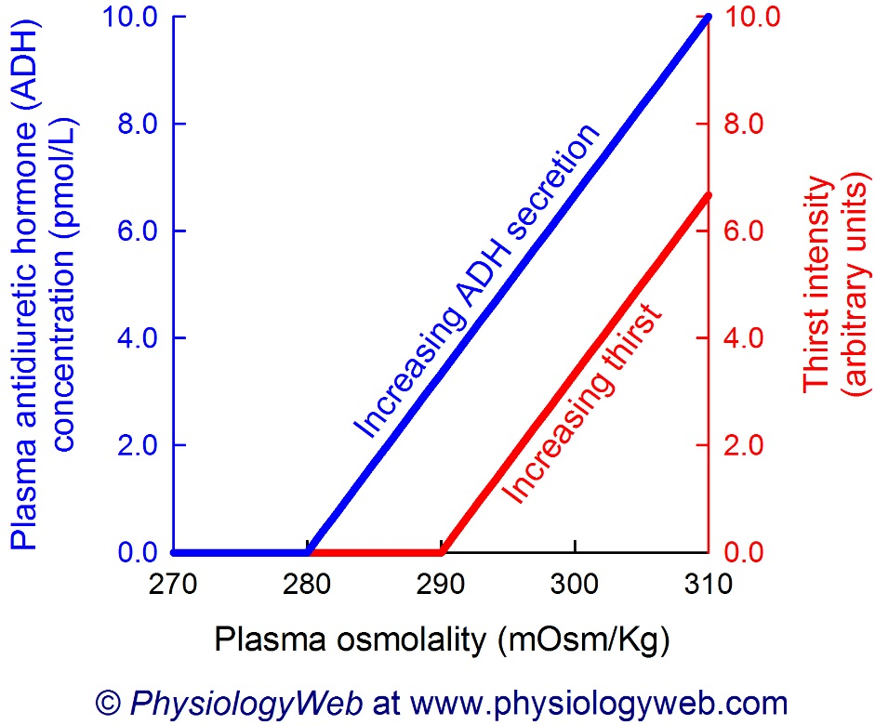

1. **The normal osmolality of extracellular fluid is 280-295 mOsmol kg-1. Identify the plasma ADH concentration at a plasma solute concentration of 295 mOsmol kg-1.**

(1 mark)

___________________________

1. **Compare the intensity of thirst and plasma ADH concentration.** (1 mark)

__________________________________________________________________________________________________________________________________________________

**Question 32 (13 marks)**

*Light for Riley* is a community campaign created after Riley Hughes, a 3 week old infant, died from Whooping Cough in a Western Australian Hospital in 2015. Since then, Riley’s mother Catherine and her husband have promoted the protection of children from vaccine-preventable diseases through the process of immunisation.

1. Describe **two (2)** different types of vaccines used, and list an example of the disease they protect against. (4 marks)

_________________________________________________________________________

__________________________________________________________________________________________________________________________________________________

_________________________________________________________________________

_________________________________________________________________________

_________________________________________________________________________

1. Local health agencies in Western Australia suggest that Whooping Cough vaccinations be given at 2, 4 and 6 months of age. State the type of immunity and likely source of antibodies for newborns between the ages of 0 and 2 months. (2 marks)

___________________________________________________________________________________________________________________________________________________________________________________________________________________________

A newborn baby was monitored for the presence of pertussis antibodies, with none detected for the first two months of life. The baby was then given the routine vaccinations at 2, 4 and 6 months of age.

1. On the following figure, draw a graph indicating the level of pertussis antibodies you would expect in the baby from the age of 2 to 12 months. (3 marks)

Level of Pertussis Antibodies (arbitrary units)

2 4 6 8 10 12

Time (months)

1. Explain the difference between an antibody and an antigen. (2 marks)

_________________________________________________________________________

___________________________________________________________________________________________________________________________________________________________________________________________________________________________

One of the driving forces behind *Light for Riley*, is the decrease in the number of children being fully immunised. The diagram below shows a number of areas within Australia with low immunisation rates.

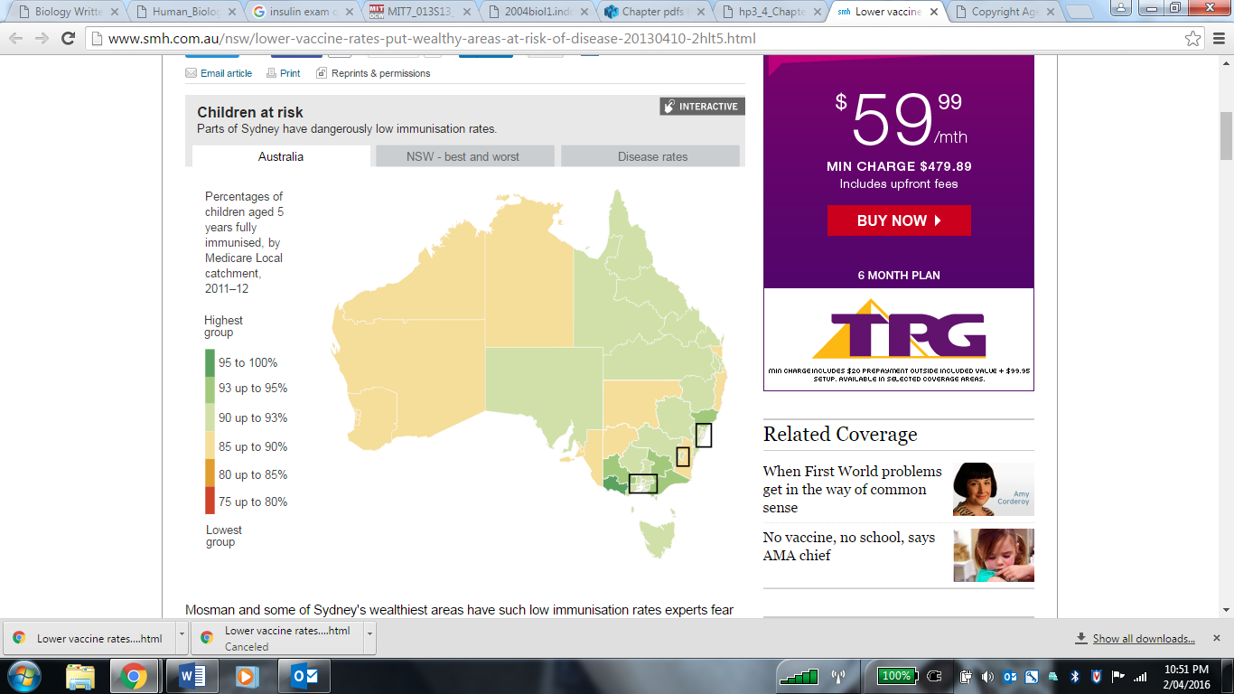

1. Discuss **one (1)** possible reason for the decline of immunisation rates in Australia.

(2 marks)

_________________________________________________________________________

___________________________________________________________________________________________________________________________________________________________________________________________________________________________

**Question 33 (20 marks)**

The Human Genome Project has allowed many applications that are advantageous to human health. In 1922 it was found that insulin from cattle and pigs could be used in humans to relieve the symptoms of diabetes in humans. The problem with this form of insulin production was that there were not enough pigs to provide the quantities needed. This led to one of the biggest breakthroughs in biotechnology: the cloning of the human insulin gene.

1. Name the organ where insulin is produced, and describe the role insulin has on controlling blood sugar levels. (3 marks)

___________________________________________________________________________________________________________________________________________________________________________________________________________________________

1. State the biotechnology technique that has been used to produce human insulin

(1 mark)

_________________________________________________

1. A transgenic organism is one which has had a foreign piece of DNA inserted into its genome artificially. State the type of transgenic organism used in the production of insulin.

(1 mark)

______________________________________________________

1. The production of a transgenic organism requires the presence of certain enzymes. Briefly explain how the following enzymes are involved in the production of a transgenic organism.

(4 marks)

Restriction enzymes: __________________________________________________________________________________________________________________________________________________

Ligase:

__________________________________________________________________________________________________________________________________________________

1. Describe the main steps involved in producing human insulin. (4 marks)

___________________________________________________________________________________________________________________________________________________________________________________________________________________________

___________________________________________________________________________________________________________________________________________________________________________________________________________________________

_____________________________________________________________________________________________________________________________________________________________________________________________________________________________________________________________________________________________________________________________________________________________________________

_________________________________________________________________________

1. Biotechnological techniques can also provide evidence for evolution. For each of the three techniques listed below, describe the feature that enables them to be used to facilitate DNA sequencing of genomes. (3 marks)

|  |  |
| --- | --- |
| **Technique** | **Feature** |
| DNA Sequencing |  |
| Profiling |  |
| Polymerase Chain Reaction |  |

1. Describe **one (1)** benefit and **one (1)** risk or ethical concern that is associated with the ongoing developments in biotechnology. (4 marks)

___________________________________________________________________________________________________________________________________________________________________________________________________________________________

__________________________________________________________________________________________________________________________________________________

**Question 34 (17 marks)**

The transmission of nerve impulses occurs via electro-chemical changes that occur where the impulse is propagated and transferred.

1. Some anticonvulsants, such as Valium (diazepam), work by allowing more chloride ions to enter a patient’s neurons, making the resting potential more negative. Explain how this would affect the ability of the neuron to generate an action potential. (2 marks)

_________________________________________________________________________

__________________________________________________________________________________________________________________________________________________

__________________________________________________________________________________________________________________________________________________

1. The disease Multiple Sclerosis (MS) damages the myelin sheath and scars the nerve cell membrane. Using your knowledge of nerve cells, explain why MS sufferers experience uncontrollable tremors. (2 marks)

_________________________________________________________________________

__________________________________________________________________________________________________________________________________________________

__________________________________________________________________________________________________________________________________________________

1. The nervous system is composed of two main divisions (Central Nervous System or CNS, and Peripheral Nervous System or PNS) and has three major functions. Identify which division and function of the nervous system are associated with the following by placing a tick in the appropriate boxes. (4 marks)

|  |  |  |  |  |  |
| --- | --- | --- | --- | --- | --- |
|  | **Division of the Nervous System** | | **Nervous System Function** | | |
|  | **CNS** | **PNS** | **Sensory** | **Integration** | **Motor** |
| **Visual Cortex** |  |  |  |  |  |
| **Secretion from glands** |  |  |  |  |  |

1. The CNS contains both grey and white matter. Name the part of the brain which connects the two hemispheres, and describe the type of matter from which it is made. (3 marks)

_________________________________________________________________________

__________________________________________________________________________________________________________________________________________________

__________________________________________________________________________________________________________________________________________________

1. Due to the delicate and vital nature of the brain and spinal cord, these parts of the body are heavily protected by various structures. Name **one (1)** of the structures and explain how it protects the CNS. (3 marks)

_________________________________________________________________________

__________________________________________________________________________________________________________________________________________________

__________________________________________________________________________________________________________________________________________________

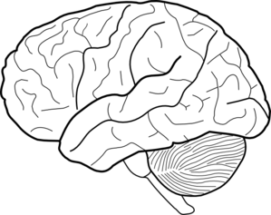

B

A

1. Referring to the diagram above, briefly explain how parts A and B work together to enable a skier to glide smoothly across the snow. (3 marks)

_________________________________________________________________________

__________________________________________________________________________________________________________________________________________________

__________________________________________________________________________________________________________________________________________________

**Question 35 (13 marks)**

1. Down’s syndrome and Cri-du-chat are caused by chromosomal mutations. Explain why a chromosomal mutation can result in severe effects compared to that of gene mutations.

(2 marks)

_________________________________________________________________________

__________________________________________________________________________________________________________________________________________________

_________________________________________________________________________

1. The biological definition of evolution is the change of allele frequencies in a population over time. Using an example within a human population, summarise Darwin’s Theory of Evolution by Natural Selection . (6 marks)

_________________________________________________________________________

__________________________________________________________________________________________________________________________________________________

_________________________________________________________________________

__________________________________________________________________________________________________________________________________________________

__________________________________________________________________________________________________________________________________________________

_________________________________________________________________________

__________________________________________________________________________________________________________________________________________________

_________________________________________________________________________

West Nile Virus (WNV) is currently on the rise in Western Countries, such as North America, and is known to lethally infect humans. Studies have found that the protein CCR5(+), and its mutated form CCR5∆32, are associated with WNV susceptibility. The table below shows the distribution of genotypes in patients with and without WNV in Northern America.

|  |  |  |  |
| --- | --- | --- | --- |
| Genotype: | +/+ | +/∆32 | ∆32/∆32 |
| Patients with WNV | 321 | 78 | 18 |
| Patients without WNV | 155 | 16 | 2 |

1. Using the data above, the allelic frequency of **CCR5∆32** homozygotes was calculated and is stated below.

Patients with WNV: 0.04

Patients without WNV: 0.01

Given that the percentage of **CCR5∆32 homozygotes** in North America is usually 1 percent, compare frequency of **CCR5∆32 homozygotes** in both populations.

(2 marks)

_________________________________________________________________________

__________________________________________________________________________________________________________________________________________________

_________________________________________________________________________

1. Propose an explanation for the data, stating whether an advantage is present.

(3 marks)

_________________________________________________________________________

__________________________________________________________________________________________________________________________________________________

_________________________________________________________________________

**Question 36 (15 marks)**

An experiment was conducted on the effects of exercise on breathing rate. The experiment involved subjects doing intervals of exercise which increased in length and measured their breathing rate during the rest periods. The experiment involved 30 subjects. All subjects were required to stay in a small room maintained at a temperature of 25°C and were asked to run at 8km/h on a treadmill for 30 seconds. After this, the subjects rest for 45 seconds whilst their breathing rate was measured over 15 seconds. Each interval was increased by 10 seconds until a total length of 180 seconds was reached. The results were averaged and are presented below.

|  |  |
| --- | --- |
| **Length of time of exercise (seconds)** | **Breathing Rate**  **(breaths per minute)** |
| Resting | 46 |
| 30 | 53 |
| 60 | 53 |
| 90 | 63 |
| 120 | 65 |
| 150 | 73 |
| 180 | 77 |

1. i) Propose a hypothesis for the experiment (1 mark)

______________________________________________________________________________________________________________________________________

ii) List **two (2)** variables that were controlled in the experiment (2 marks)

______________________________________________________________________________________________________________________________________

1. Suggest how researchers could increase the
   * 1. Validity of the experiment (1 mark)

____________________________________________________________________________________________________________________________________

* + 1. Reliability of the results (1 mark)

____________________________________________________________________________________________________________________________________

1. Graph the data in the table on the grid below (5 marks)



1. Explain how increases in levels of carbon dioxide in the blood cause the breathing rate to increase over the experiment. (3 marks)

_________________________________________________________________________

___________________________________________________________________________________________________________________________________________________________________________________________________________________________

__________________________________________________________________________________________________________________________________________________

1. Valsalva is a technique associated with breath-holding and is often used in weight-training. Describe how this conscious control of breathing may have dangerous consequences.

(2 marks)

_________________________________________________________________________

___________________________________________________________________________________________________________________________________________________________________________________________________________________________

__________________________________________________________________________________________________________________________________________________

**Question 37 (14 marks)**

Scientific evidence shows that the physical and behavioural traits shared by all modern humans originated from apelike ancestors. It is believed that *Ardipithecus ramidus* was an early ancestral hominin living approximately 4.5 million years ago in what is now known as Ethiopia.

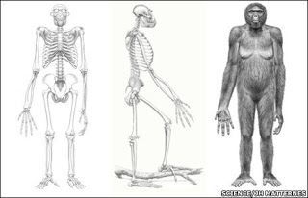

1. *Ardipithecus ramidus* has characteristics of both apes and humans. Describe **two (2)** pieces of evidence that suggests *Ardipithecus ramidus* could was bipedal. (4 marks)

__________________________________________________________________________________________________________________________________________________________________________________________________________________________________________________________________________________________________________________________________________________________________________________________________________________________________________________________________________________________________________________________________________________________________________________________________________________________________________________________________________________________________________________________________________________________

1. Four of the main hominid tool cultures are Oldowan, Acheulean, Mousterian, and Solutrean. Describe at least **two (2)** of the trends (design, manufacture, or material) in the tool cultures over time. (4 marks)

Trend One: ­­­­­­­­­­­­­­________________________________________________________________

___________________________________________________________________________________________________________________________________________________________________________________________________________________________

_________________________________________________________________________

Trend Two: ­­­­­­­­­­­­­­________________________________________________________________

___________________________________________________________________________________________________________________________________________________________________________________________________________________________

_________________________________________________________________________

1. Fossil remains of *A. afarensis* discovered in the 1970’s show that bipedal locomotion evolved before changes occurred in the skull. State the trend in cranial capacity between lemurs, monkeys, chimpanzees and humans, and describe an advantage of this trend. (3 marks)

___________________________________________________________________________________________________________________________________________________________________________________________________________________________

__________________________________________________________________________________________________________________________________________________

__________________________________________________________________________________________________________________________________________________

1. Explain how mitochondrial DNA provides evidence for human evolution. (3 marks)

___________________________________________________________________________________________________________________________________________________________________________________________________________________________

__________________________________________________________________________________________________________________________________________________

__________________________________________________________________________________________________________________________________________________

**Section Three: Extended answer 20% (40 Marks)**

This section contains **three (3)** questions. You must answer **two (2)** questions. Make sure you clearly indicate which question you are answering and write your answers in the space provided.

Spare pages are included at the end of this booklet. They can be used for planning your responses and/or as additional space if required to continue an answer.

* Planning: If you use the spare pages for planning, indicate this clearly at the top of the page.
  + Continuing an answer: If you need to use more space to continue an answer, indicate in the original answer space where the answer is continued, i.e. give the page number. Write the number of the question(s) that you are continuing to answer at the top of the additional space page.

Responses could include clearly labelled diagrams with explanatory notes; lists of points with linking sentences; clearly labelled tables and graphs; and annotated flow diagrams with introductory notes.

Suggested working time: 40 minutes.

**Question 38 (20 marks)**

Darwin voyaged on the *HMS Beagle* visiting Australia, New Zealand and the Galapagos Islands, amongst many others. He observed similarities and differences in species separated by both time and space.

1. Explain why unique species are found on remote islands, like the Galapagos, compared to islands found closer to the mainland. (8 marks)
2. Biotechnological techniques have enabled more accurate evidence for the theory of evolution.
   * 1. Briefly explain the importance of PCR, bacterial enzymes and gel electrophoresis in regards to evidence of evolution. (4 marks)
     2. Briefly describe biochemical evidence that supports the understanding that collections of species share a recent common ancestor. (4 marks)
     3. Briefly describe anatomical evidence that supports the understanding that collections of species share a recent common ancestor. (4 marks)

**Question 39 (20 marks)**

The vertebral column of humans is designed to support the weight of the head and torso with minimum use of energy. This trend of S-shaped spines was noted in the earliest Australopithecines, and is a significant feature associated with bipedalism.

1. Name the **two (2)** curves that are found in the S-shaped spine, and state how they contribute to an upright stance. (4 marks)
2. Alongside skeletal changes, there has been a trend of increasing cognitive abilities and lifestyles with human evolution. Describe the significance of tool development and use for hominin evolution.

(8 marks)

1. A new genetic study has revealed that genes inherited from Neanderthals 50,000 years ago have played a key role in our immune system today. Describe the events that occur in the humoral immune response and explain how the effects of invading microorganisms are overcome.

(8 marks)

**Question 40 (20 marks)**

Complex neural pathways are involved in the processing of information and therefore require a certain amount of time between the recognition of a stimulus and the resulting response. For some stimuli, a reflex arc will replace this typical stimulus-response pathway.

1. Describe **two (2)** ways that reflex arcs differ from a typical transmission pathway, and suggest why reflex arcs are considered protective. (4 marks)
2. Extreme fear can result in many physical changes. Describe the nervous and hormonal changes that would take place during this experience. (8 marks)
3. Homeostasis, also known as a Neural or Autonomic Reflex, is designed to maintain a human body’s internal environment within certain limits. Describe the steps associated with maintaining concentrations of gas via the respiratory system. (8 marks)

Question number: ________________

_____________________________________________________________________________________________________________________________________________________________________________________________________________________________________________________________________________________________________________________________________________________________________________________________________________________________________________________________________________________________________________________________________________________________________________________________________________________________________________________________________________________________________________________________________________________________________________________________________________________________________________________________________________________________________________________________________________________________________________________________________________________________________________________________________________________________________________________________________________________________________________________________________________________________________________________________________________________________________________________________________________________________________________________________________________________________________________________________________________________________________________________________________________________________________________________________________________________________________________________________________________________________________________________________________________________________________________________________________________________________________________________________________________________________________________________________________________________________________________________________________________________________________________________________________________________________________________________________________________________________________________________________________________________________________________________________________________________________________________________________________________________________________________________________________________________________________________________________________________________________________________________________________________________________________________________________________________________________________________________________________________________________________________________________________________________________________________________________________________________________________________________________________________

Question number: ________________

_____________________________________________________________________________________________________________________________________________________________________________________________________________________________________________________________________________________________________________________________________________________________________________________________________________________________________________________________________________________________________________________________________________________________________________________________________________________________________________________________________________________________________________________________________________________________________________________________________________________________________________________________________________________________________________________________________________________________________________________________________________________________________________________________________________________________________________________________________________________________________________________________________________________________________________________________________________________________________________________________________________________________________________________________________________________________________________________________________________________________________________________________________________________________________________________________________________________________________________________________________________________________________________________________________________________________________________________________________________________________________________________________________________________________________________________________________________________________________________________________________________________________________________________________________________________________________________________________________________________________________________________________________________________________________________________________________________________________________________________________________________________________________________________________________________________________________________________________________________________________________________________________________________________________________________________________________________________________________________________________________________________________________________________________________________________________________________________________________________________________________________________________________________

Question number: ________________

_____________________________________________________________________________________________________________________________________________________________________________________________________________________________________________________________________________________________________________________________________________________________________________________________________________________________________________________________________________________________________________________________________________________________________________________________________________________________________________________________________________________________________________________________________________________________________________________________________________________________________________________________________________________________________________________________________________________________________________________________________________________________________________________________________________________________________________________________________________________________________________________________________________________________________________________________________________________________________________________________________________________________________________________________________________________________________________________________________________________________________________________________________________________________________________________________________________________________________________________________________________________________________________________________________________________________________________________________________________________________________________________________________________________________________________________________________________________________________________________________________________________________________________________________________________________________________________________________________________________________________________________________________________________________________________________________________________________________________________________________________________________________________________________________________________________________________________________________________________________________________________________________________________________________________________________________________________________________________________________________________________________________________________________________________________________________________________________________________________________________________________________________________________

Question number: ________________

_____________________________________________________________________________________________________________________________________________________________________________________________________________________________________________________________________________________________________________________________________________________________________________________________________________________________________________________________________________________________________________________________________________________________________________________________________________________________________________________________________________________________________________________________________________________________________________________________________________________________________________________________________________________________________________________________________________________________________________________________________________________________________________________________________________________________________________________________________________________________________________________________________________________________________________________________________________________________________________________________________________________________________________________________________________________________________________________________________________________________________________________________________________________________________________________________________________________________________________________________________________________________________________________________________________________________________________________________________________________________________________________________________________________________________________________________________________________________________________________________________________________________________________________________________________________________________________________________________________________________________________________________________________________________________________________________________________________________________________________________________________________________________________________________________________________________________________________________________________________________________________________________________________________________________________________________________________________________________________________________________________________________________________________________________________________________________________________________________________________________________________________________________________

Question number: ________________

_____________________________________________________________________________________________________________________________________________________________________________________________________________________________________________________________________________________________________________________________________________________________________________________________________________________________________________________________________________________________________________________________________________________________________________________________________________________________________________________________________________________________________________________________________________________________________________________________________________________________________________________________________________________________________________________________________________________________________________________________________________________________________________________________________________________________________________________________________________________________________________________________________________________________________________________________________________________________________________________________________________________________________________________________________________________________________________________________________________________________________________________________________________________________________________________________________________________________________________________________________________________________________________________________________________________________________________________________________________________________________________________________________________________________________________________________________________________________________________________________________________________________________________________________________________________________________________________________________________________________________________________________________________________________________________________________________________________________________________________________________________________________________________________________________________________________________________________________________________________________________________________________________________________________________________________________________________________________________________________________________________________________________________________________________________________________________________________________________________________________________________________________________________

Question number: ________________

_____________________________________________________________________________________________________________________________________________________________________________________________________________________________________________________________________________________________________________________________________________________________________________________________________________________________________________________________________________________________________________________________________________________________________________________________________________________________________________________________________________________________________________________________________________________________________________________________________________________________________________________________________________________________________________________________________________________________________________________________________________________________________________________________________________________________________________________________________________________________________________________________________________________________________________________________________________________________________________________________________________________________________________________________________________________________________________________________________________________________________________________________________________________________________________________________________________________________________________________________________________________________________________________________________________________________________________________________________________________________________________________________________________________________________________________________________________________________________________________________________________________________________________________________________________________________________________________________________________________________________________________________________________________________________________________________________________________________________________________________________________________________________________________________________________________________________________________________________________________________________________________________________________________________________________________________________________________________________________________________________________________________________________________________________________________________________________________________________________________________________________________________________________

Question number: ________________

_____________________________________________________________________________________________________________________________________________________________________________________________________________________________________________________________________________________________________________________________________________________________________________________________________________________________________________________________________________________________________________________________________________________________________________________________________________________________________________________________________________________________________________________________________________________________________________________________________________________________________________________________________________________________________________________________________________________________________________________________________________________________________________________________________________________________________________________________________________________________________________________________________________________________________________________________________________________________________________________________________________________________________________________________________________________________________________________________________________________________________________________________________________________________________________________________________________________________________________________________________________________________________________________________________________________________________________________________________________________________________________________________________________________________________________________________________________________________________________________________________________________________________________________________________________________________________________________________________________________________________________________________________________________________________________________________________________________________________________________________________________________________________________________________________________________________________________________________________________________________________________________________________________________________________________________________________________________________________________________________________________________________________________________________________________________________________________________________________________________________________________________________________________

Spare Graph Paper for Question 36



**Reference List**

*Multiple Choice*

Question 12, Karyotype - <https://commons.wikimedia.org/wiki/File%3AKaryotype.Translocation%2BDeletion.Schematic.gif>

Question 15, Founder Effect –

<https://commons.wikimedia.org/wiki/File:Founder_effect_Illustration.jpg>. Illustration is modelled on “Genetic Drift.” Boundless Biology. Boundless, 21 Jan. 2015. Retrieved 13 May. 2015 from <https://www.boundless.com/biology/textbooks/boundless-biology-textbook/the-evolution-of-populations-19/population-genetics-131/genetic-drift-531-11736/>

Question 18, Cave Fish –

<https://commons.wikimedia.org/wiki/File%3AFMIB_51868_Blind_Cave-fish%2C_Typhlichthys_subterraneus_Girard_Mammoth_Cave%2C_Kentucky.jpeg> Acknowledgement of the Freshwater and Marine Image Bank at the University of Washington, as a source for this photograph.

Question 18, Minnow –

<https://commons.wikimedia.org/wiki/File%3AFMIB_51388_Top_Minnow_Gambusia_affinis_Male.jpeg> Acknowledgement of the Freshwater and Marine Image Bank at the University of Washington, as a source for this photograph.

Question 22, Primate Dental Arcades –

<http://australianmuseum.net.au/image/dental-arcade-of-an-ape-australopithecus-africanus-and-a-modern-human>. Acknowledgement of Helen Beare and the Australian Museum as a source for this graph.

*Short Answer*

Question 31, Hormone Actions –

<https://commons.wikimedia.org/wiki/File:Steroid_and_Lipid_Hormones.svg>

Question 31, ADH Graph –

<http://www.physiologyweb.com/figures/figs/plasma_osmolality_antidiuretic_hormone_thirst_jpg_Jp65SHzc7JevVyWbzR79O0cFcuXHPQmq.html>

Question 32, Australian Vaccine Rates –

<http://www.smh.com.au/nsw/lower-vaccine-rates-put-wealthy-areas-at-risk-of-disease-20130410-2hlt5.html>. Acknowledgement of the Sydney Morning Herald, as a source for this figure.

Question 34, Brain Diagram –

<http://www.clker.com/clipart-brain-clipart-without-eye.html>

Question 37, Ardipithecus ramidus –

<http://attitudeadj.blogspot.com.au/2009/10/ardipithecus-ramidus-15-or-4400000.html>